RESOLUTION324-25-41 APPROVING SECOND AMENDMENT TO THE 2023

RENEWAL CONTRACT FOR TOWNSEND COMMUNITY SCHOOL

The Board of Education of the Margaretta Local School District (the "Board"), Erie County, Ohio, met in regular session on the 16th day of December, 2024, at the offices of said Board, with the following members present:

Mr. Hula, Mr. Lippert, Mr. Schoenegge, Mr. Sutorius, and Mrs. Tucker.

The Treasurer advised the Board that the notice requirements of R.C. 121.22 and the implementing rules adopted by the Board pursuant thereto were complied with for the meeting.

Mr. Lippert moved the adoption of the following Resolution:

WHEREAS, the Board and the Governing Authority of Townsend Community School ("TCS") are parties to a sponsor contract and desire to amend the Contract to reflect changes in TCS's facilities.

NOW, THEREFORE, BE IT RESOLVED, by the Board of Education of the Margaretta Local School District, Castalia, Ohio, that:

Section l. The Board hereby approves the Second Amendment to the Renewal Contract for Townsend Community School.

Section 2. The Superintendent is hereby authorized and directed to execute the Second Amendment to the 2023 Renewal Contract for Townsend Community School upon receiving a fully executed lease for the new Fremont facility.

Section 3. It is hereby found and determined that all formal actions of this Board concerning and relating to the adoption of this resolution were adopted in an open meeting of the Board, and that all deliberations of this Board and any of its committees that resulted in such formal actions were in meetings open to the public, in compliance with all legal requirements including Section 121.22 of the Ohio Revised Code, and any amendments thereto.

Mr. Sutorius seconded the Motion and upon roll call, the vote resulted as follows:

All Ayes

Motion passed and adopted this 16th day of December, 2024.

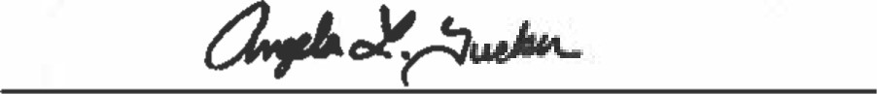

Angie Tucker, President, Board of Education

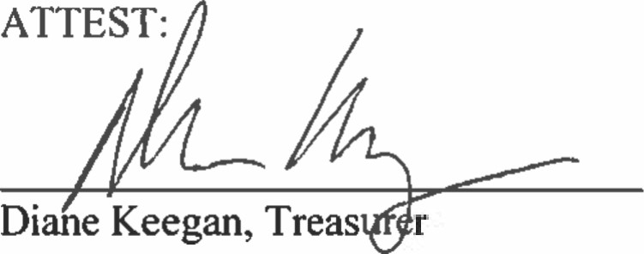

2

SECOND AMENDMENT TO THE

2023 RENEWAL CONTRACT FOR

TOWNSEND COMMUNITY SCHOOL

This Second Amendment to the 2023 Renewal Contract for Townsend Community School ("Second Amendment") is entered as of January l, 2025, amending the 2023 Renewal Contract for Townsend Community School ("Renewal Contract"), by and between Margaretta Local School District Board of Education ("SPONSOR") and Townsend Community School ("SCHOOL").

WHEREAS, the SCHOOL notified the SPONSOR of its desire to operate out of a different location in Fremont, Ohio and R.C. 3314.05 permits the SCHOOL to use multiple locations.

NOW, THEREFORE, the parties modify the Renewal Contract as follows:

Section 6, Subsection (a) and (b) of the Agreement are amended and restated as follows:

1. The SCHOOL is located at the facilities specified below (collectively, the "TCS Facility").

207 Lowell Street, Castalia, Ohio 44824 (the "Castalia Learning Center"). The Castalia Learning Center is a two-story building, which contains classrooms, common areas, and office spaces for teachers and administrators. The annual costs associated with leasing the facility from the Landlord, Margaretta Local School District, are $5,400.00. As TCS does not have an operator, the District is not related to the operator.

138 Market Street, Sandusky, Ohio 44870 (the "Sandusky Learning Center"). The Sandusky Learning Center is located in the second floor at the Sandusky Artisans Cooperative and contains office and classroom space for teachers and students. The annual costs associated with the lease of the facility from the Landlord, Sandusky Artisans Cooperative, are $0. As TCS does not have an operator, the Sandusky Artisans Cooperative is not related to the operator.

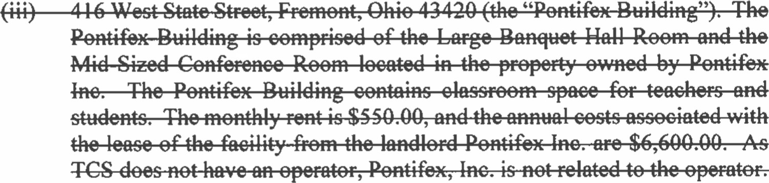

* 1. 2830 Napoleon Road, Fremont, Ohio, 42430 ("Fremont Facility"). The Fremont Facility contains classroom space for teachers and students. The monthly rent is $550.00, and the annual costs associated

with the lease of the facility from the Landlord, Terra State Community College, are $6,600.00. As TCS does not have an operator, the Landlord is not related to the operator. Use of the Fremont Facility shall not begin until at least ten (10) business days after the SPONSOR submits opening assurances to the Ohio Department of Education and Workforce.

* 1. 1005 N. Abbe Rd, Elyria, Ohio, 44035 Rooms UC 210 and 207 or equivalent ("LCCC Facility). The LCCC Facility contains classroom space for teachers and students. The monthly rent is $550.00, and the annual costs associated with the lease of the facility from the Landlord, Lorain County Community College, are $6,600.00. As TCS does not have an operator, Lorain County Community College is not related to the operator. Use of the LCCC Facility shall not begin until at least ten (10) business days after the SPONSOR submits opening assurances to the Ohio Department of Education.

1. The SCHOOL represents that it is authorized to use the Castalia Learning Center, the Sandusky Learning the Fremont Facility, and the LCCC Facility pursuant to R.C. Accordingly, the SCHOOL may assign students in the same grade level to multiple facilities. The SCHOOL shall not utilize other locations or facilities for educational purposes without the SPONSOR's prior written approval.

2. The Parties agree that the terms of this Amendment will be incorporated into the Renewal Contract between the Parties. All other terms and conditions of the Renewal Contract shall remain in full force and effect. This Amendment represents the entire agreement between the Parties with respect to its subject matter and shall only be amended by a signed writing.

SPONSOR: SCHOOL:

Margaretta Local School District Governing Authority of

Board of Education Townsend Community School

By:

Its: Superintendent Its: Superintendent

|  |  |  |
| --- | --- | --- |
| la |  | 2 |
|  | |  |

Date: Date; 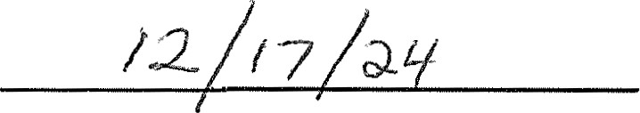

2